**Text To Pay**

By

**Four Musks**

Nihal Kaul

Utsav Rawat

Ninad Marathe

Jaya Krishna Thupili

GitHub Link: <https://github.com/sjsu-4musks/text-to-pay-app.git>

https://github.com/sjsu-4musks/text-to-pay-api.git

**Project Description**

Introduction:

The 'Text to Pay' project is an innovative venture that aims to revolutionize the way businesses handle transactions and interact with their customers. Recognizing the need for an effective and efficient way to facilitate payments, this project introduces a method that enables consumers to make payments via text messages. The underlying goal of the 'Text to Pay' project is to streamline the payment process, improve customer engagement, and ultimately increase conversion rates and customer retention for businesses across various sectors.

Methodology:

The 'Text to Pay' application operates on a simple, user-friendly interface where businesses send a text message to their customer's phone, indicating the possibility of making a payment. Customers have the option to reply with "yes" to complete the transaction. The system securely stores customers' payment information, eliminating the need to enter it for every transaction. New customers are onboarded through a secure link where they enter their payment details only once. After that, their phone number becomes their payment method, ensuring a seamless experience for future transactions.

'Text to Pay' is a serverless application running on AWS Lambda. The sign-up and sign-in form is authorized and authenticated using Auth0 login via a Gmail account. The backend API are deployed in the lambda function and the API gateway is used to trigger the APIs. The backend code is written in Nodejs. The front end is designed using Reactjs. For front-end deployment, we leveraged Amazon S3 and integrated it with Cloudfront. S3 ensures the data is highly scalable, highly available, fast, and secure. CloudFront caches the content across multiple distribution servers located close to our users, significantly reducing latency and providing a smoother user experience.

Results:

The 'Text to Pay' project has shown promising results. Businesses using the system have reported an increase in customer engagement and a notable improvement in conversion rates. The simplified payment process has led to enhanced customer satisfaction, resulting in higher retention rates. New customers have also found the onboarding process straightforward and secure, leading to a greater number of sign-ups. Moreover, secure transactions have minimized the risk of data breaches and fraud, providing both businesses and customers with a sense of security.

On the customer side, the feedback is positive. The convenience and speed of the 'Text to Pay' system has been highly appreciated. The ability to make payments without the need to enter payment information every time has made the process efficient and hassle-free.

**Project Requirements**:

Technology and Resource Requirements:

| **Keyword** | **Definitions** |
| --- | --- |
| Frontend | The name of the project |
| Backend | A person in charge of organizing the team and communicating with the project supervisor |
| Programming | An active member of the team responsible for making the job done |
| DataBase | A time in a project that marks the end of a project phase or the completion of an important deliverable. |
| Cloud Services | The version control system that will be used in this project |

**High-Level Architecture Design**

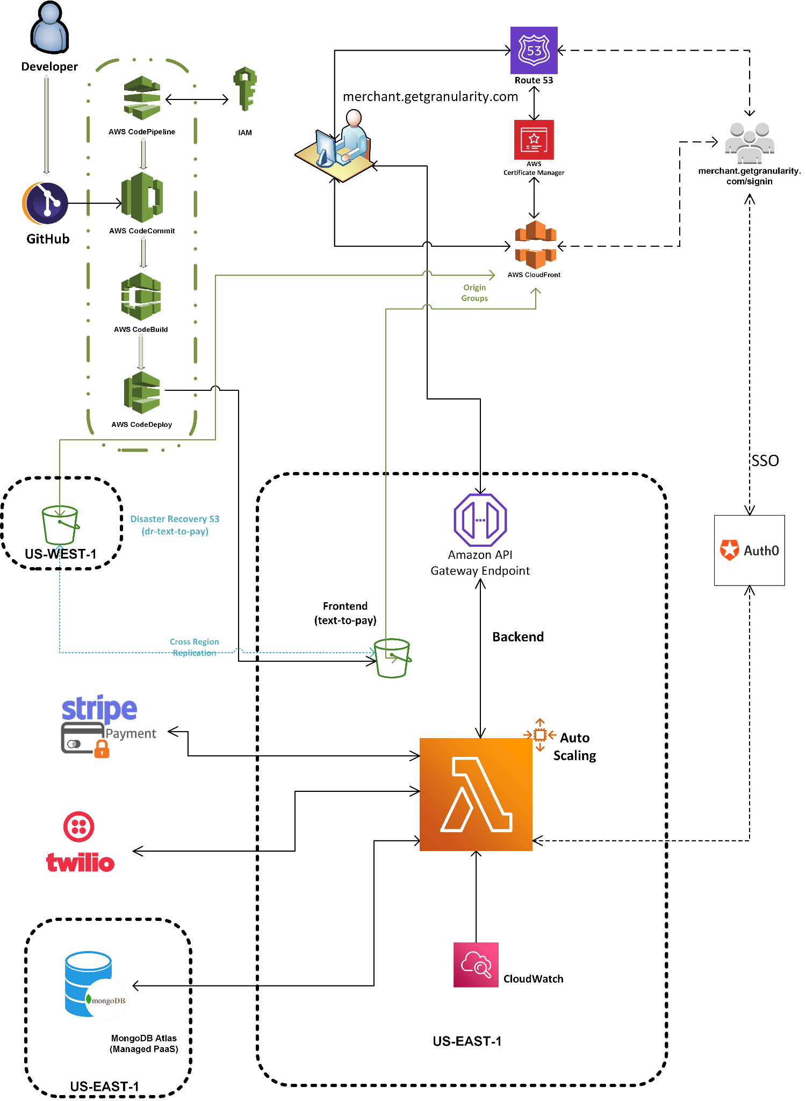

**UseCase Sequence Diagram**

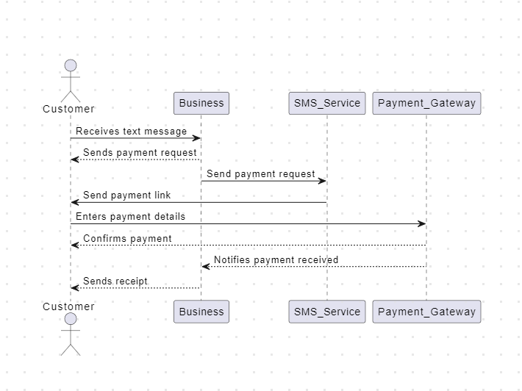

**UML Class Diagram**

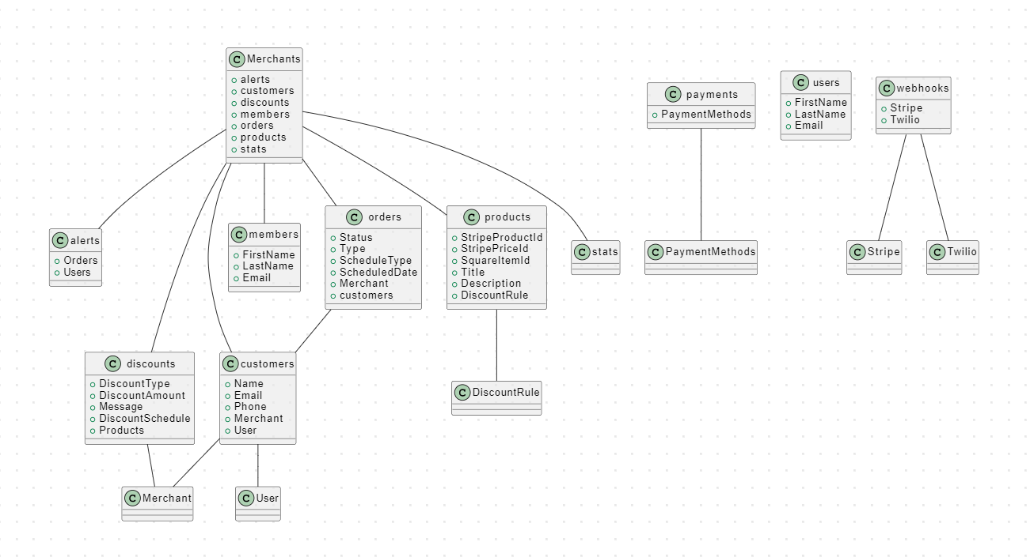

**Data Flow Diagram**

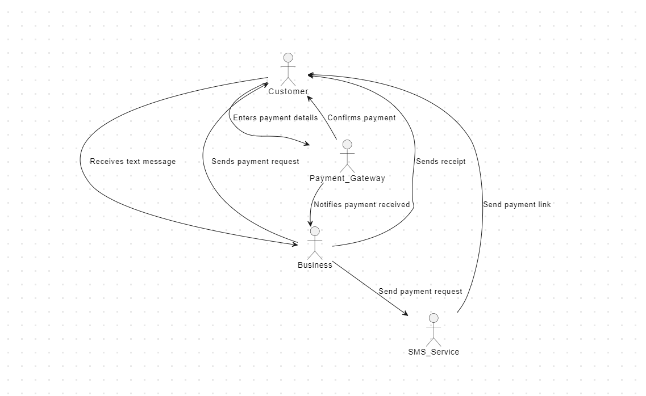

**Testing (Data Validation):**

Testing is a critical aspect of the software development lifecycle for any application, including the 'Text to Pay' project. The following testing methodologies have been employed to ensure that the application is functional, reliable, and secure:

•Unit Testing: The 'Text to Pay' project utilizes unit testing to verify the correctness of individual functions and components. Unit tests are designed to test a specific piece of code in isolation and ensure that each component works as intended.

•Integration Testing: Integration testing is used to test how different components of the 'Text to Pay' application work together. This testing method ensures that the application functions correctly as a whole and catches any issues that may not be identified during unit testing.

•End-to-End Testing: End-to-End testing simulates real user interactions with the 'Text to Pay' application and verifies that the system functions as expected from a user's perspective. This testing method ensures that the application performs as intended under normal usage scenarios.

•Performance Testing: Performance testing evaluates the 'Text to Pay' application's ability to handle a high volume of transactions and user requests. Performance testing simulates high-traffic scenarios to identify any performance bottlenecks and ensure that the application can handle the expected load.

•Security Testing: Security testing is conducted to identify and mitigate any security vulnerabilities in the 'Text to Pay' application. This testing method ensures that user data is protected and the system is secure from potential threats, such as SQL injection and cross-site scripting attacks.

Through comprehensive testing, the 'Text to Pay' project has proven to be functional, reliable, and secure. The results of testing have shown that the application streamlines the payment process, improves customer engagement, increases conversion rates, and enhances customer retention. The simplified payment process has led to enhanced customer satisfaction, resulting in higher retention rates. Moreover, secure transactions have minimized the risk of data breaches and fraud, providing both businesses and customers with a sense of security.

Overall, the 'Text to Pay' project has undergone rigorous testing to ensure that it meets the expectations of businesses and customers. By leveraging a variety of testing methodologies, developers have been able to identify and address any issues early in the development process, resulting in a successful project that addresses the evolving needs of businesses and consumers alike.

**Design Patterns Used**

Serverless Architecture Pattern: The Text-to-Pay platform is built using a serverless architecture pattern, which means that it does not require any server infrastructure to run. Instead, the platform utilizes AWS Lambda functions to execute code and process requests, which allows for greater scalability and cost-effectiveness.

Model-View-Controller (MVC) Pattern: The Text-to-Pay platform follows the Model-View-Controller (MVC) pattern, which separates the application into three distinct components: the Model, the View, and the Controller. The Model represents the data and the business logic, the View is responsible for displaying the data to the user, and the Controller handles user input and communicates with the Model and View.

Repository Pattern: The Text-to-Pay platform utilizes the Repository pattern, which separates the data access logic from the rest of the application. This allows for greater flexibility and modularity in the application, as the data access layer can be easily swapped out or modified without affecting the rest of the application.

Singleton Pattern: The Text-to-Pay platform uses the Singleton pattern to ensure that certain components of the application, such as the database connection, are only instantiated once and shared throughout the application. This helps to improve performance and reduce resource usage.

Overall, the use of these design patterns in the Text-to-Pay platform helps to ensure that the application is well-structured, scalable, and maintainable. By separating concerns and managing dependencies effectively, the platform provides a high-quality user experience while being easy to maintain and modify.

**Data Engineering**

Data engineering is a crucial component of the 'Text to Pay' project, responsible for managing and processing payment data in a secure, efficient, and scalable manner. The project leverages cutting-edge technologies and methodologies to ensure that payment data is collected, stored, and processed seamlessly.

The system utilizes a serverless architecture running on AWS Lambda, which allows for efficient and cost-effective deployment and scaling of the backend APIs. Auth0 login via Gmail is used to authenticate and authorize users, ensuring a secure sign-up and sign-in process.

The payment information is securely stored, reducing the need for customers to enter their payment details repeatedly, and enhancing the payment experience. The payment system is straightforward, and businesses can send payment requests via text messages, making the process fast and hassle-free for customers.

The backend code is written in Nodejs, and the front-end is designed using Reactjs, providing a responsive and user-friendly interface. Amazon S3 is used for data storage, which ensures high scalability, availability, and security of the payment data. CloudFront is integrated to cache the content, reducing latency and providing a smoother user experience.

The 'Text to Pay' project has demonstrated excellent results, with businesses reporting increased customer engagement, higher conversion rates, and improved customer retention. Customers have appreciated the convenience and speed of the payment system, making it more efficient and hassle-free.

**Text-to-pay**

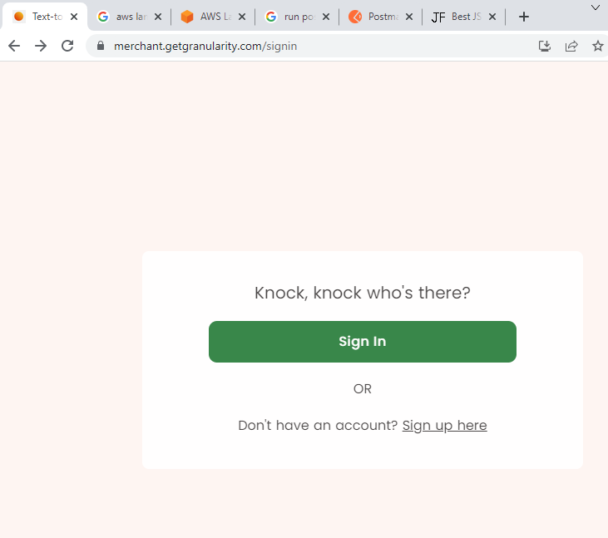

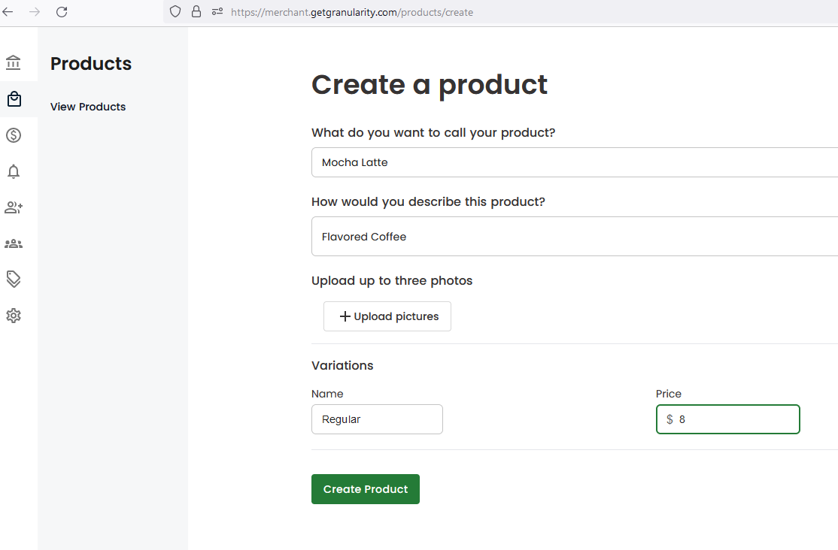

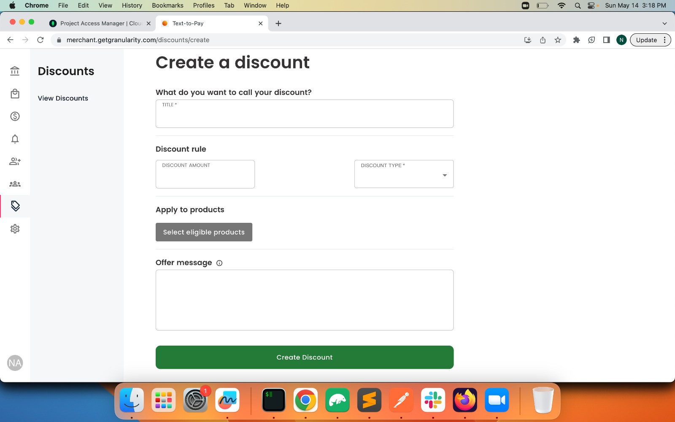

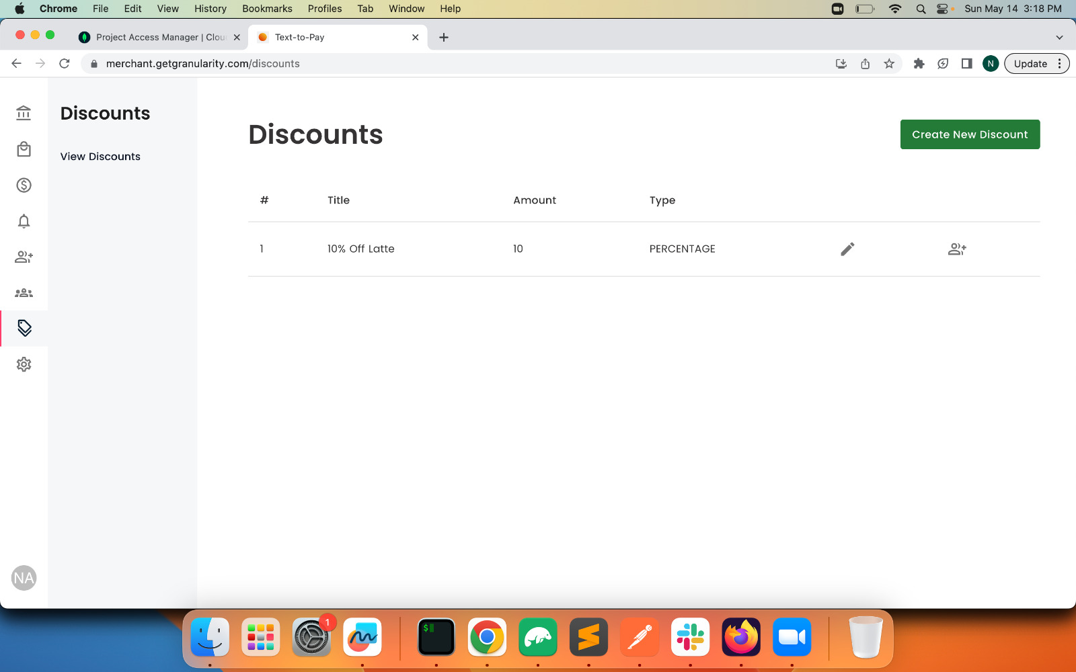

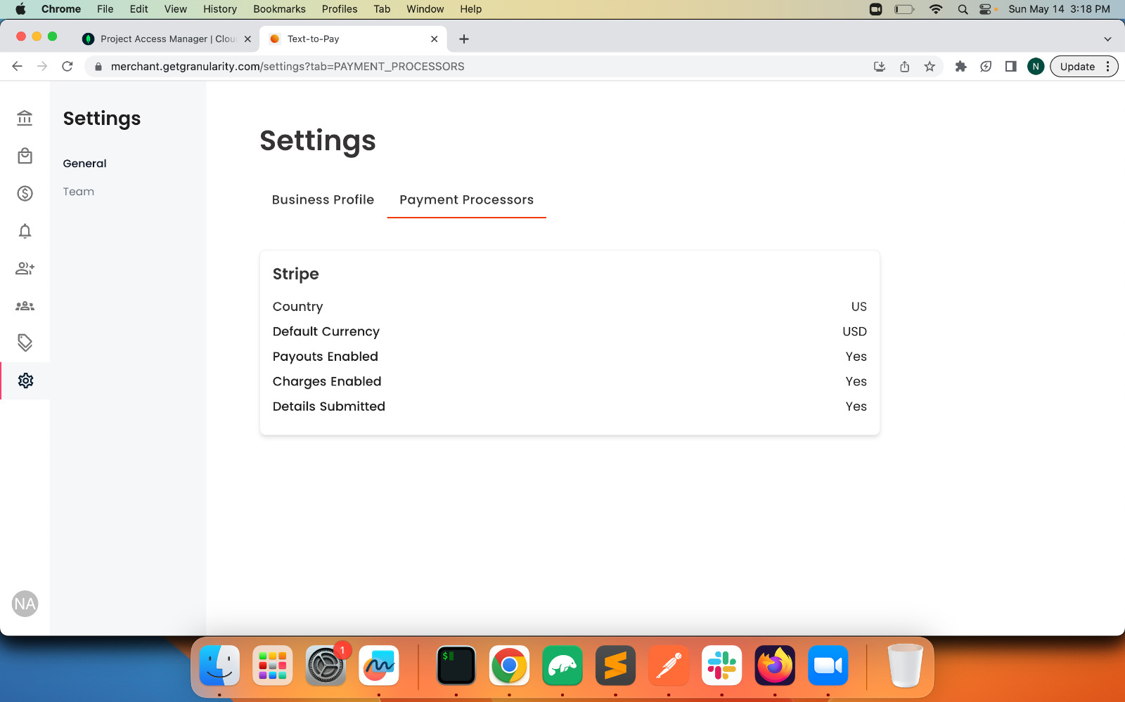

**Order via SMS:**

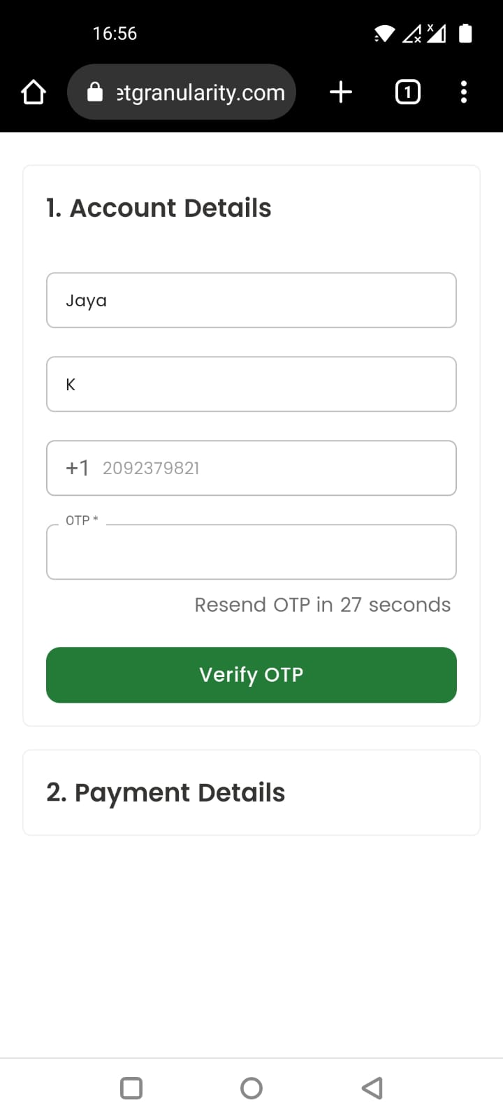 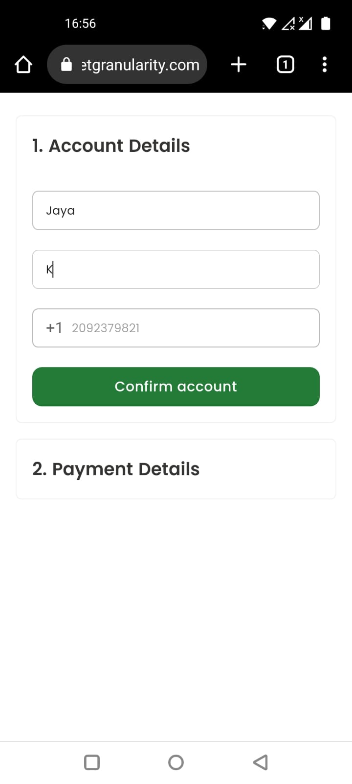

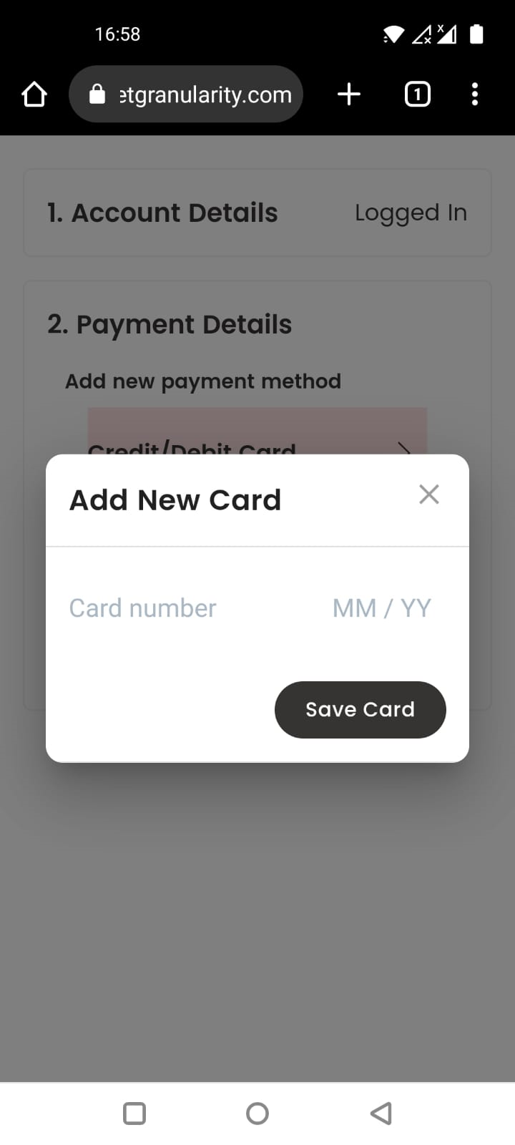 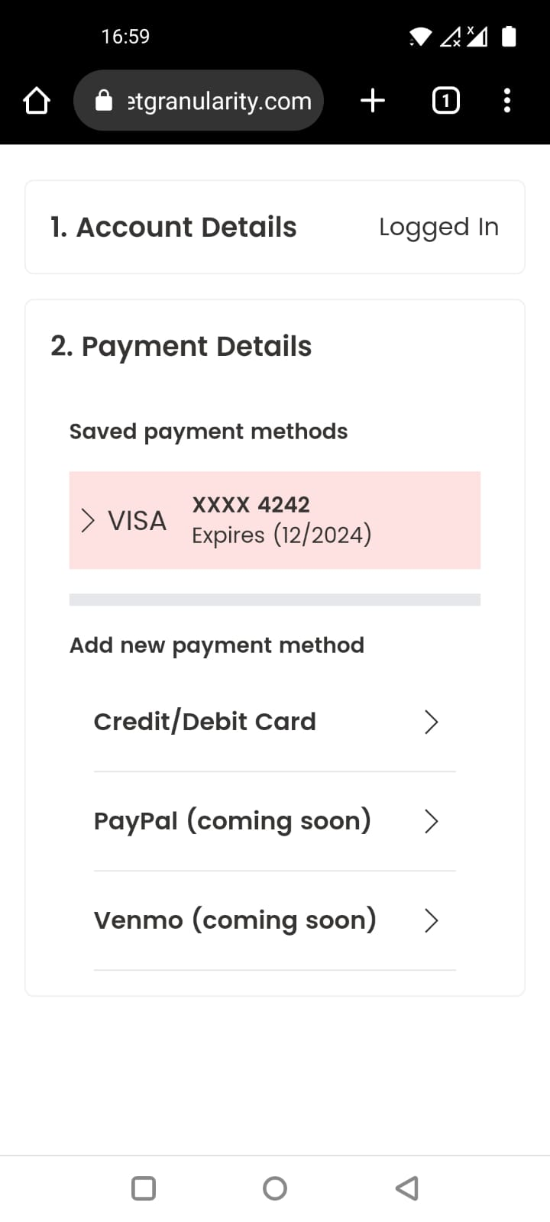

**AWS Configurations**

**CloudPipeline**

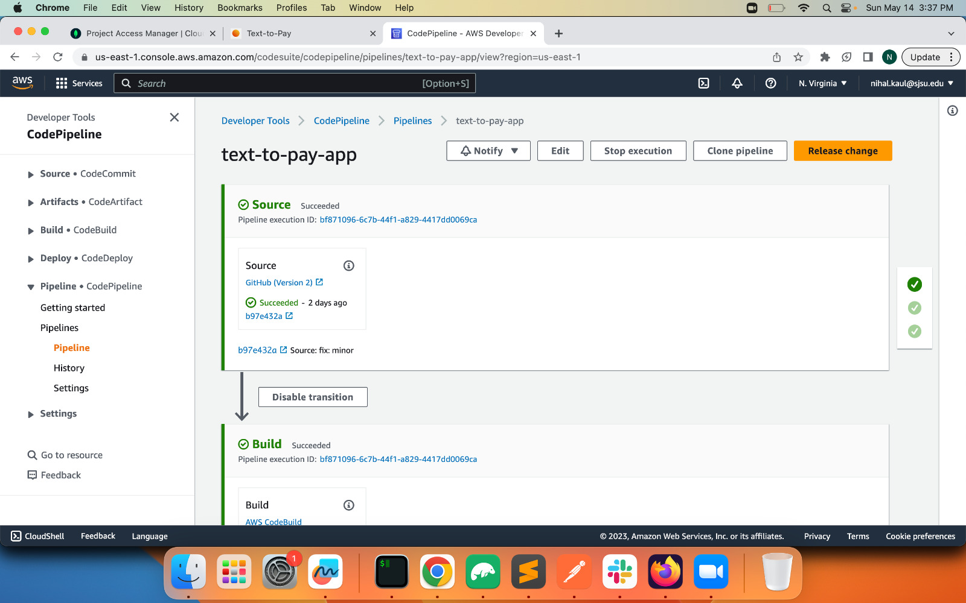

**Frontend S3 bucket**

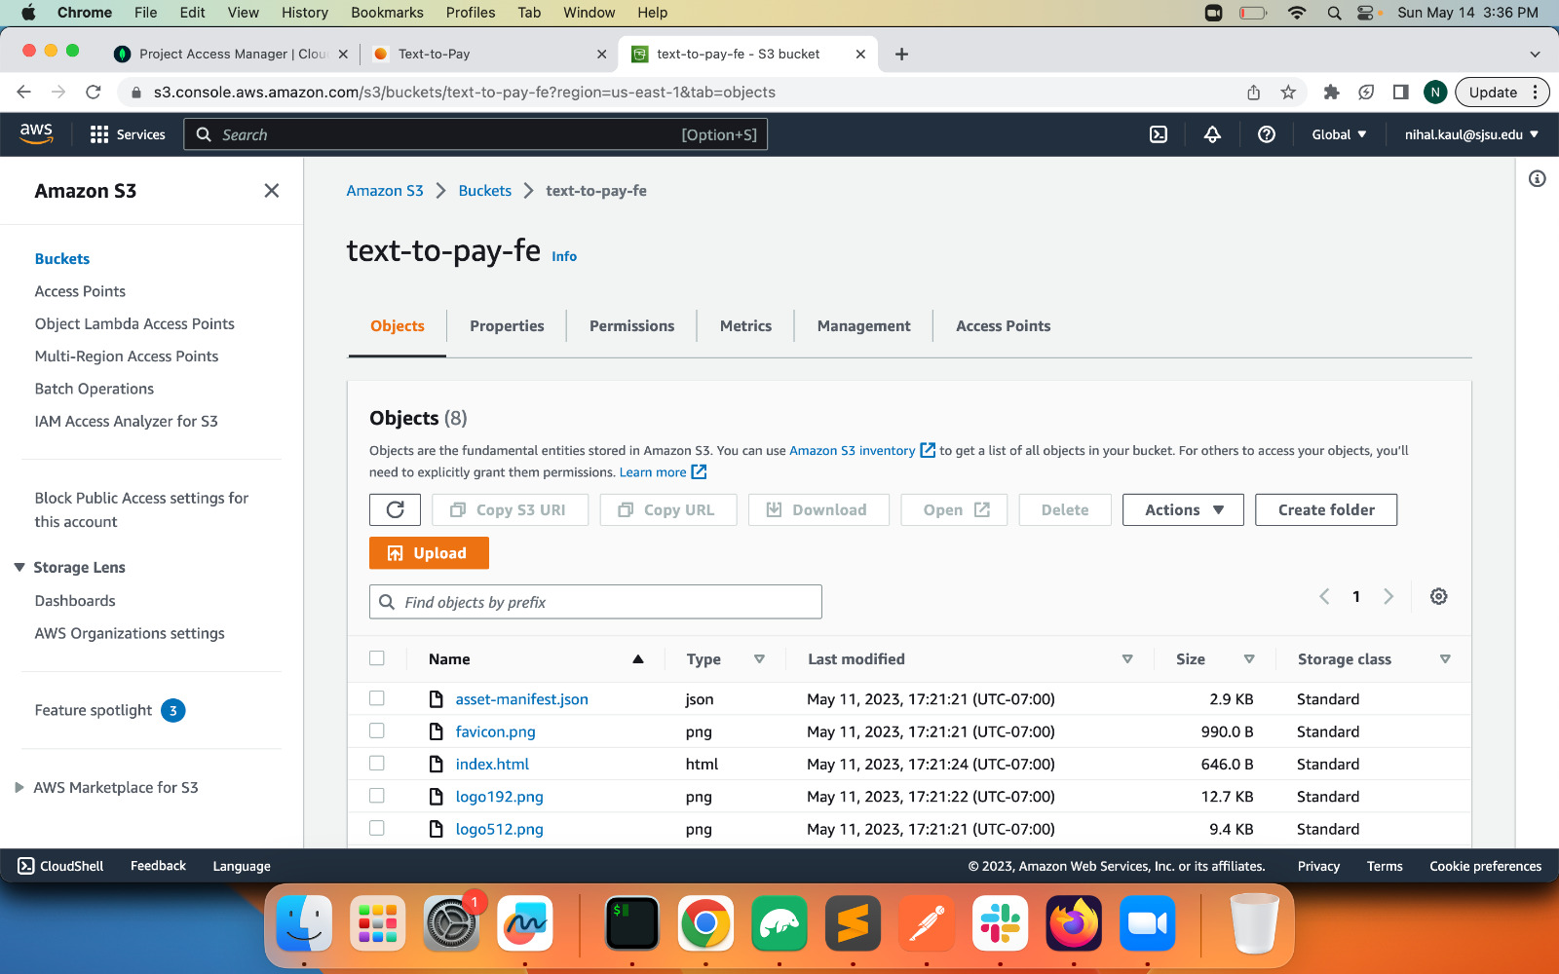

**Cloudfront Distribution**

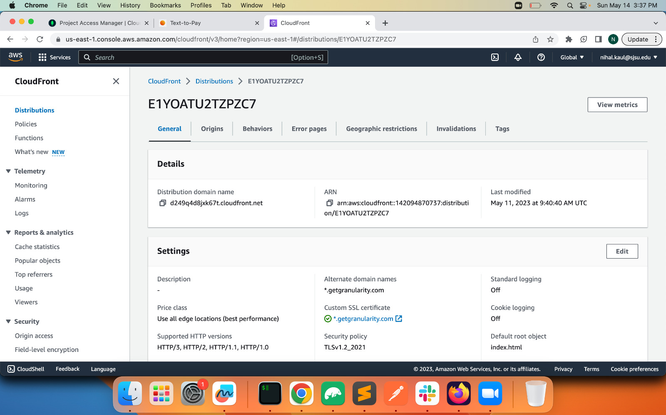

**SSL Certificate for Secure Domain**

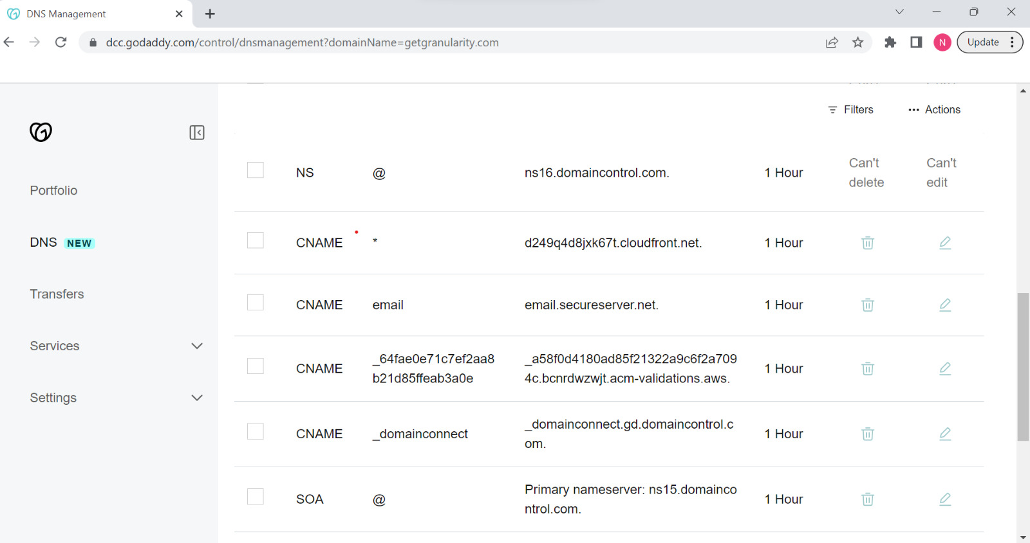

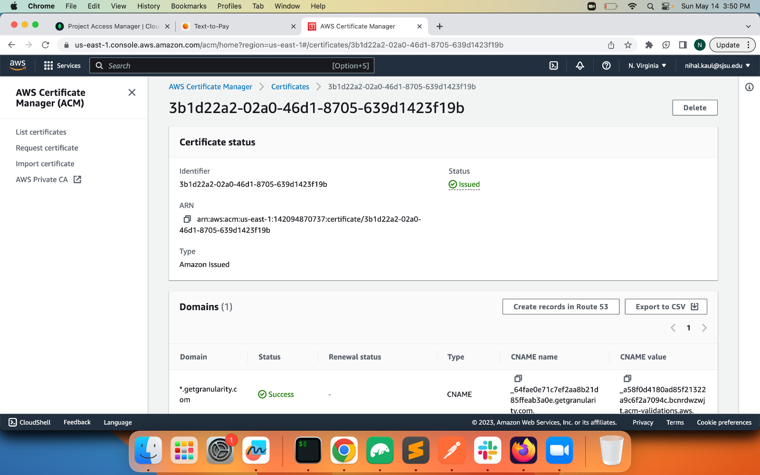

**AWS Lambda for backend:**

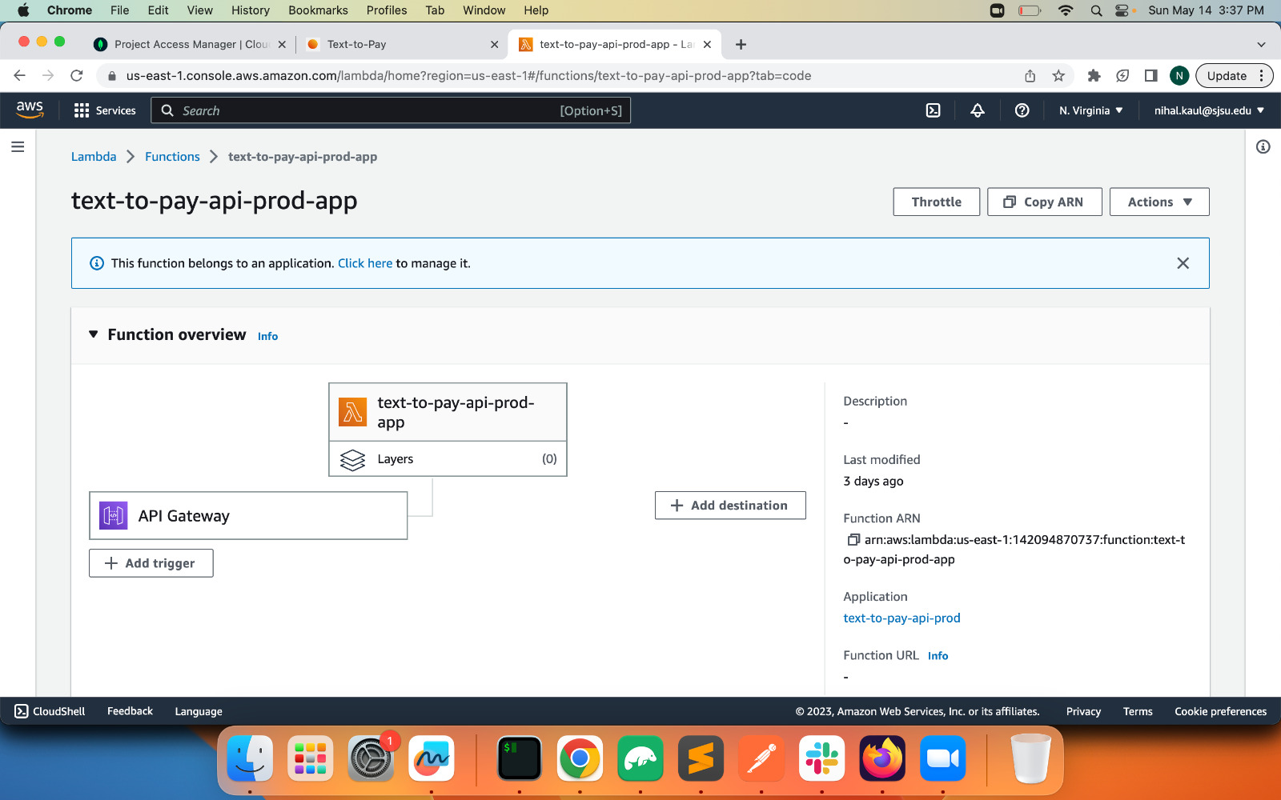

**Stripe Connectors:**

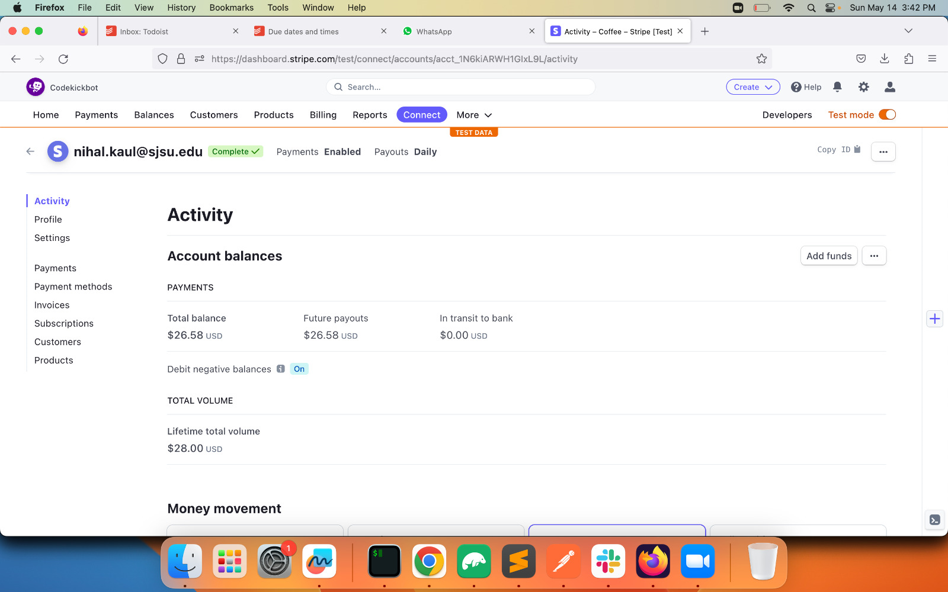

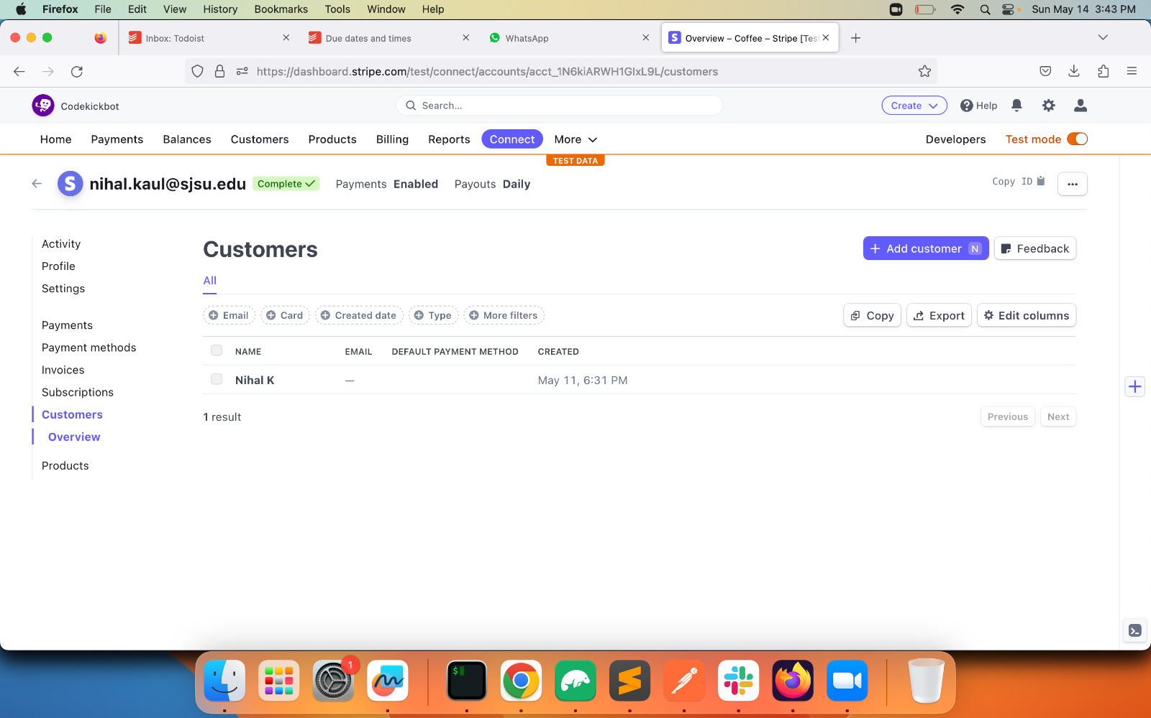

**Stripe Payment info:**

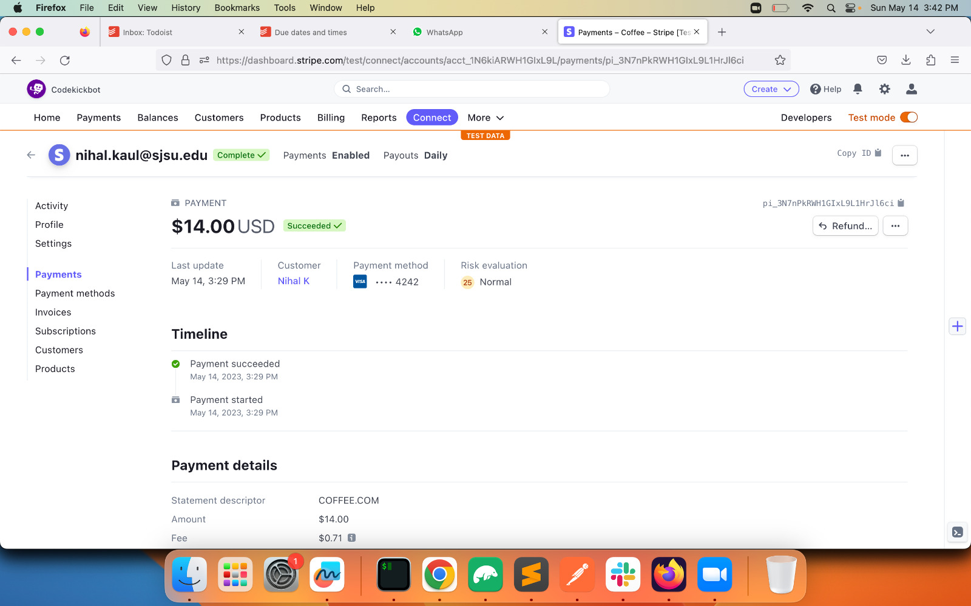

**Twilio for SMS webhooks:**

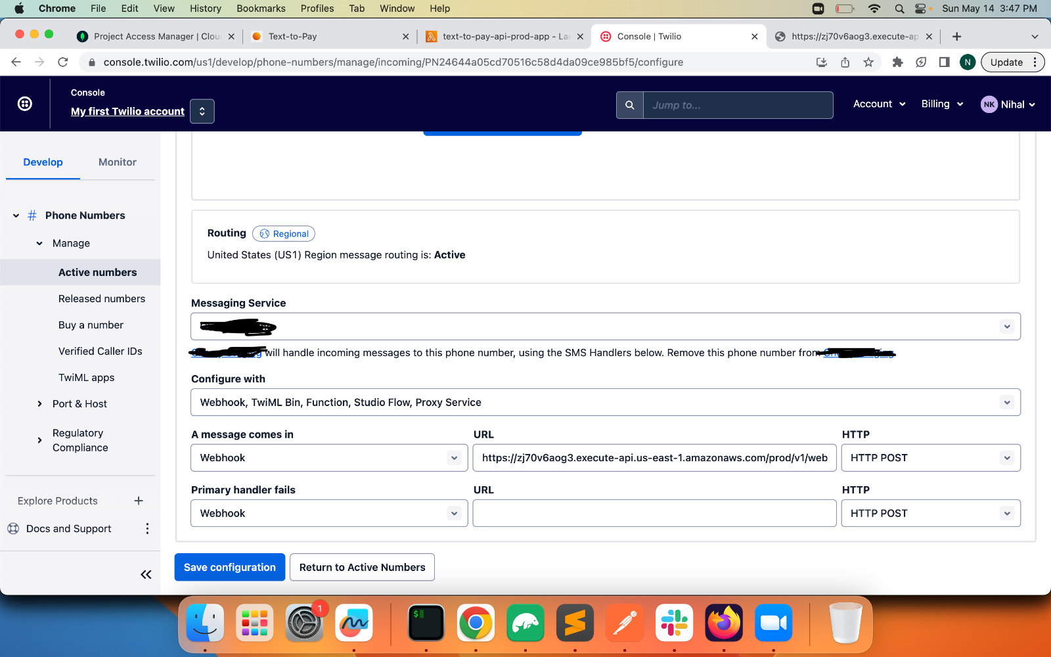

**Mongodb Atlas:**

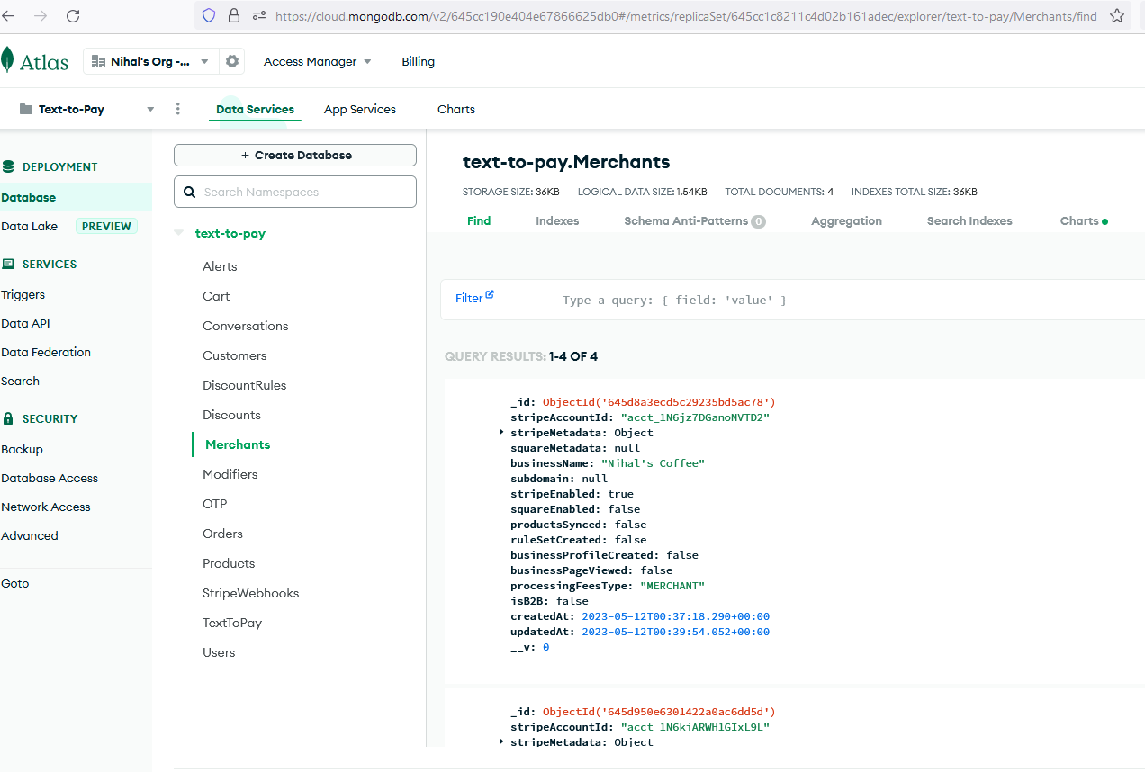

**Unit Testing**

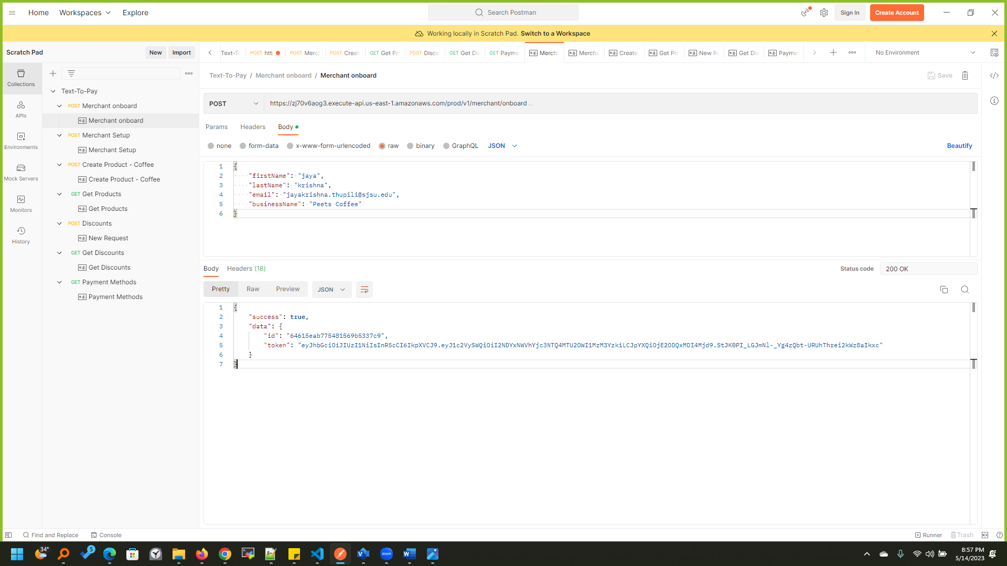

**Conclusion**

In conclusion, the 'Text to Pay' project has demonstrated that it is possible to create a secure, efficient, and user-friendly payment system that caters to the needs of both businesses and customers. By leveraging cutting-edge technologies such as serverless computing, AWS Lambda, and Auth0 login, the project has created a seamless payment experience that eliminates the need for customers to enter payment information for every transaction. The results of the project have been promising, with businesses reporting increased engagement, higher conversion rates, and enhanced customer satisfaction. The feedback from customers has also been positive, with many appreciating the convenience and speed of the system. Overall, the 'Text to Pay' project stands as a testament to the power of innovation and technology in shaping the future of business transactions.

# References

* Twillio logo (<https://www.stickpng.com/img/icons-logos-emojis/tech-companies/twilio-full-logo>)
* Stripe Logo (<https://www.stickpng.com/img/icons-logos-emojis/tech-companies/stripe-payment-logo>)
* MongoDB Atlas ([https://www.mongodb.com](https://www.mongodb.com/))
* AWS Resources logo([https://aws.amazon.com/architecture/icons](https://aws.amazon.com/architecture/icons/))